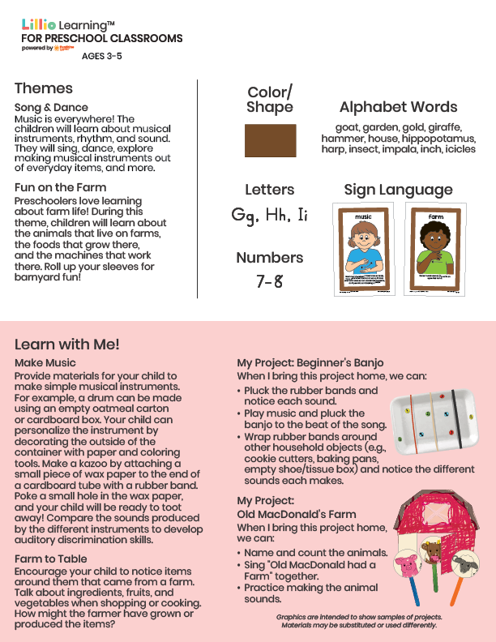­

November 2025

Newsletter

Add Your Name/Logo Here

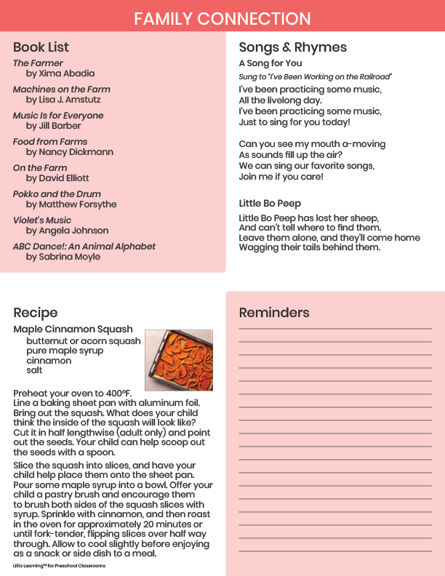

Add Notes